# Easily Replace a Colour in your Photos

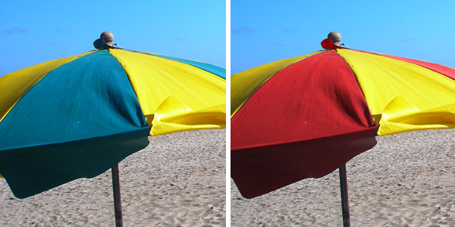

The **Colour Replacement brush** is a tool that lets you paint with one colour over another colour, keeping the brightness and contrast of the image. This way you can easily change the colour of an object without using complex masking and colour correction tools.

We are going to replace the colour of these beach parasols from blue to red and leave the yellow part untouched.

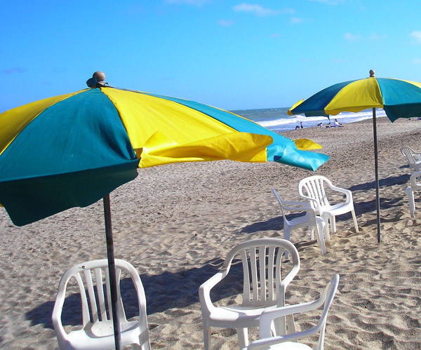

Select the **Colour Replacement tool** from the tools palette.

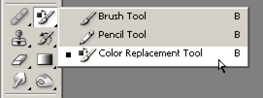

Look at the **preferences** bar.

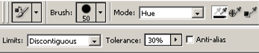

There are many settings you can change. In this case we will use the following: **Brush Size: 50 px** (Set the size of the brush according to the resolution of the image. You will need a medium to large brush for large areas, and a small one to paint the details). Select  to change the **Mode** setting to **Hue. Sampling: Continuous** (the first Eyedropper icon). Select  **Limits set to Discontiguous** **. Select**  **Tolerance to 40%. Select**  **Anti-alias, Unchecked**. I will explain the meaning of these settings later.

Using a vivid red colour as the foreground, start painting over of the beach parasol taking care that the center crosshair doesn’t leave the blue area that you are painting on. You don’t have to be very precise when using this tool. As you paint, it will only replace the colours that are stepped over by the crosshair, leaving the other colours untouched. In this case when the crosshair is over the blue colour, the yellow colours will be left untouched.

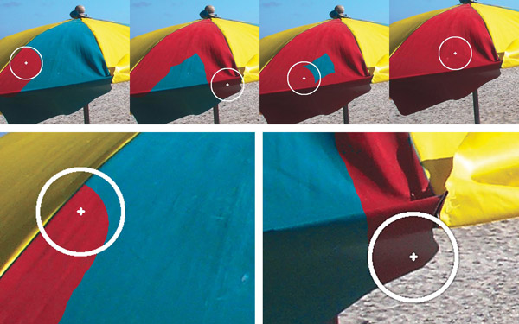

There are some situations where the colour to be replaced is similar to an adjacent colour resulting in unwanted areas being painted. Unfortunately the only solution to this problem is to decrease the brush size and paint with a little more care, see pic below.

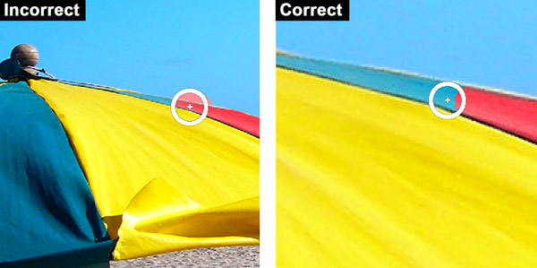

You may need to repeat the process until you acquire some practice, mostly with the difficult spots where two similar colours are very close or along edges. But it shouldn’t take long until you manage to replace the blue colour from the beach parasols.

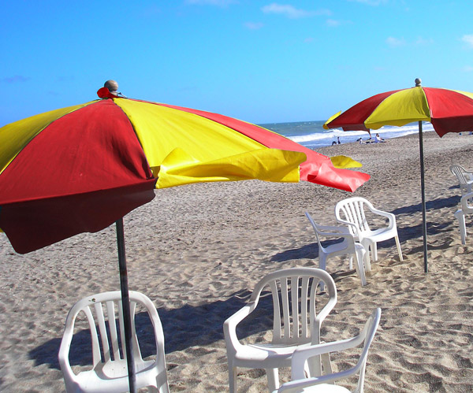

There is no need to go in depth with the Colour Replacement tool settings. The settings we used in this tutorial are ok with most cases. Anyway, there are two settings that are worthy to be explored when you are using this tool for the first time.

The **Mode** setting has four options. The most useful are **Hue** and **Colour**. If you choose **Hue**, you will replace only the tint (hue) of the underlying colour and the saturation and luminosity will remain untouched. But if you choose **Colour** as the painting mode, you will replace both the hue and saturation of the underlying colour leaving the luminosity without any changes.

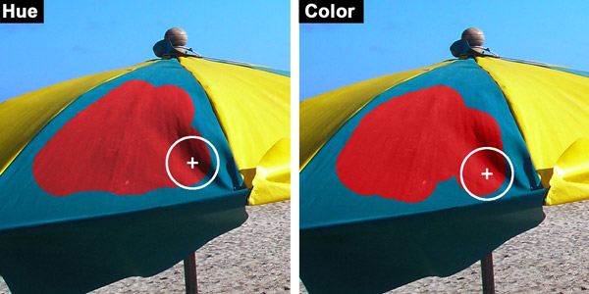

The other setting is the Tolerance. It works much like the paint bucket and wand tools tolerance setting. With a large tolerance the **Colour Replacement tool** will paint over colours that are distant to the one being sampled by the brush tip crosshair. On the contrary, if you choose a small tolerance, only the colours that are close to the sampled colour will be replaced.

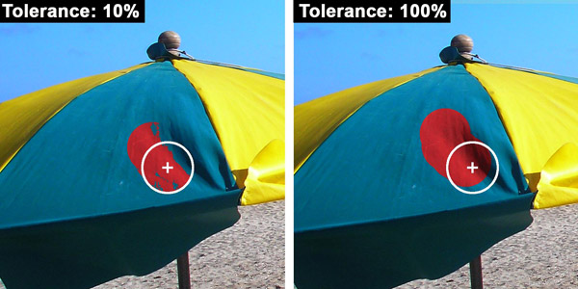

That’s all you need to know to start using this wonderful and fun tool. When you become more familiar with it, you will be able to explore other settings and you will find that it is perhaps the easiest way of changing colours in a photograph.